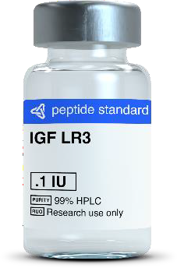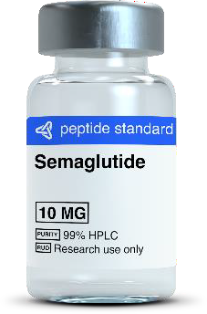Reconstitute and shipping not included in cost

|  |  |  |
| --- | --- | --- |
| AOD9604 | 2mg/vial | **$ 36.00** |
| BPC 157 | 2mg/vial | **$ 27.00** |
|  | 5mg/vial | **$ 36.00** |
|  | 10mg/vial | **$ 60.00** |
| CJC-1295 with DAC | 2mg/vial | **$ 36.00** |
| CJC-1295 without | 2mg/vial | **$ 30.00** |
| DAC | 5mg/vial | **$ 48.00** |
| Cagrilintide | 5mg/vial | **$ 90.00** |
| 10mg/vial |
| DSIP | 10mg/vial | **$ 54.00** |
| Epithalon | 10mg/vial | **$ 45.00** |
| GHK-Cu (Human | 50mg/vial | **$ 39.00** |
| Copper tri-peptide) | 100mg/vial | **$ 54.00** |
| GHRP - 2 | 2mg/vial | **$ 21.00** |
|  | 5mg/vial | **$ 39.00** |
| HCG | 5000iu/vial | **$ 75.00** |
| HGH 10iu | 10iu/vial | **$ 36.00** |
| IGF LR3 | 1mg/vial | **$ 144.00** |
|  | 0.1mg/vial | **$ 45.00** |
| Ipamorelin | 2mg/vial | **$ 27.00** |
|  | 5mg/vial | **$ 54.00** |
|  | 10mg/vial | **$ 75.00** |
| Kisspeptin -10 | 5mg/vial | **$ 45.00** |
| MOTS - C | 10mg/vial | **$ 54.00** |
| Melanotan II | 10mg/vial | **$ 27.00** |
| NAD+ | 500mg/vial | **$ 84.00** |
| Oxytocin Acetate | 8mg/vial | **$ 54.00** |
| PT - 141 | 10mg/vial | **$ 54.00** |
| Selank | 5mg/vial | **$ 54.00** |
| Semaglutide | 2mg/vial | **$ 45.00** |
|  | 5mg/vial | **$ 84.00** |
|  | 10mg/vial | **$ 120.00** |
| Semax | 10mg/vial | **$ 60.00** |
| Sermorelin | 2mg/vial | **$ 45.00** |
|  | 5mg/vial | **$ 81.00** |
| Snap-8 | 10mg/vial | **$ 45.00** |

|  |  |
| --- | --- |
| 10vial/kit | **$ 360.00**  **$ 270.00**  **$ 360.00**  **$ 600.00**  **$ 360.00**  **$ 300.00**  **$ 480.00**  **$ 900.00**  **$ 540.00**  **$ 450.00**  **$ 390.00**  **$ 540.00**  **$ 210.00**  **$ 390.00**  **$ 750.00**  **$ 360.00**  **$ 1,440.00**  **$ 450.00**  **$ 270.00**  **$ 540.00**  **$ 750.00**  **$ 450.00**  **$ 540.00**  **$ 270.00**  **$ 840.00**  **$ 540.00**  **$ 540.00**  **$ 540.00**  **$ 450.00**  **$ 840.00**  **$ 1,200.00**  **$ 600.00**  **$ 450.00**  **$ 810.00**  **$ 450.00** |
| 10vial/kit |
| 10vial/kit |
| 10vial/kit |
| 10vial/kit |
| 10vial/kit |
| 10vial/kit |
| 10vial/kit |
| 10vial/kit |
| 10vial/kit |
| 10vial/kit |
| 10vial/kit |
| 10vial/kit |
| 10vial/kit |
| 10vial/kit |
| 10vial/kit |
| 10vial/kit |
| 10vial/kit |
| 10vial/kit |
| 10vial/kit |
| 10vial/kit |
| 10vial/kit |
| 10vial/kit |
| 10vial/kit |
| 10vial/kit |
| 10vial/kit |
| 10vial/kit |
| 10vial/kit |
| 10vial/kit |
| 10vial/kit |
| 10vial/kit |
| 10vial/kit |
| 10vial/kit |
| 10vial/kit |
| 10vial/kit |
| 10vial/kit |

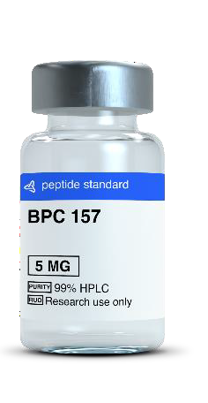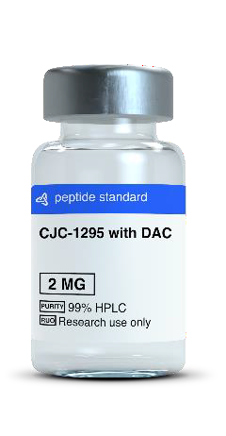

**These products are intended as research chemicals only**

**Single Vial**

**Kit Cost**

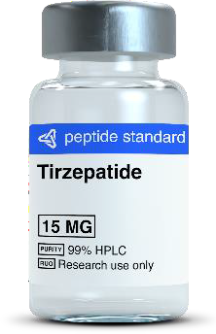

|  |  |  |
| --- | --- | --- |
| SS31 | 10mg/vial | **$ 63.00** |
| Tesamorelin | 5mg/vial | **$ 84.00** |
|  | 10mg/vial | **$ 114.00** |
| Thymosin alpha 1 | 10mg/vial | **$ 105.00** |
| Thymosin β4 (TB- | 2mg/vial | **$ 36.00** |
| 500) | 5mg/vial | **$ 63.00** |
|  | 10mg/vial | **$ 96.00** |
| Tirzepatide | 2mg/vial | **$ 45.00** |
|  | 5mg/vial | **$ 84.00** |
|  | 10mg/vial | **$ 117.00** |
|  | 15mg/vial | **$ 150.00** |
|  | 30mg/vial | **$ 210.00** |
|  | 60mg.vial | **$ 330.00** |
| Retatrutide | 10mg/vial | **$ 144.00** |

|  |  |
| --- | --- |
| 10vial/kit | **$ 630.00**  **$ 840.00**  **$ 1,140.00**  **$ 1,050.00**  **$ 360.00**  **$ 630.00**  **$ 960.00**  **$ 450.00**  **$ 840.00**  **$ 1,170.00**  **$ 1,500.00**  **$ 2,100.00**  **$ 3,300.00**  **$ 1,440.00** |
| 10vial/kit |
| 10vial/kit |
| 10vial/kit |
| 10vial/kit |
| 10vial/kit |
| 10vial/kit |
| 10vial/kit |
| 10vial/kit |
| 10vial/kit |
| 10vial/kit |
| 10vial/kit |
| 10vial/kit |
| 10vial/kit |